|  |
| --- |
| **National University of Computer and Emerging Sciences** |
| Lab Manual 12  “Creational Design Patterns: Composite and State” |
|  |
| Object Oriented Analysis and Design |
|  |

Fall 2018

Sec B and F

Department of Computer Science

FAST-NU, Lahore, Pakistan

**Question # 1**

**Task (i)**

**Read following link to understand composite pattern.**

<https://www.tutorialspoint.com/design_pattern/composite_pattern.htm>

**Task (ii)**

The Composite composes objects into tree structures and lets clients treat individual objects and compositions uniformly. Although the example is abstract, arithmetic expressions are Composites. An arithmetic expression consists of an operand, an operator (+ - * /), and another operand. The operand can be a number, or another arithmetic expression. Thus, 2 + 3 and (2 + 3) + (4 * 6) are both valid expressions.

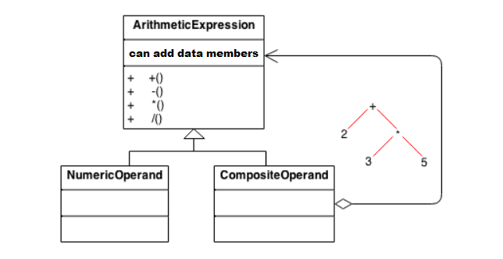

The numeric Operand class will have list of numeric operands. And Composite Operand class will have list of Arithmetic Expressions. Arithmetic Expressions is a abstract class.